NIWA

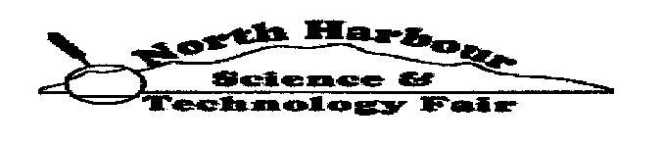

NIWA
NORTH HARBOUR

SCIENCE & TECHNOLOGY

FAIR

Information
about
Ethics
for
Staff and Students

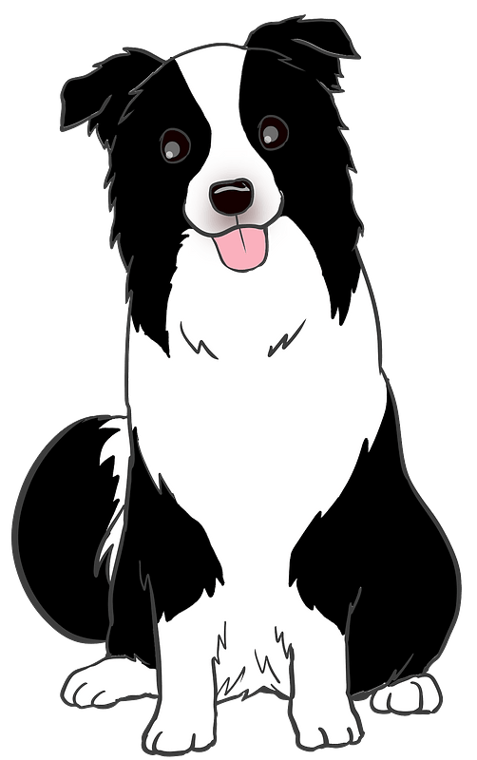

The New Zealand Association of Science Educators
“Ethics approval is legally required under the Animal Welfare Act 1999 when live animals are to be used for teaching or research depending on what animal they are and if they are ‘manipulated’. This often applies to student investigations including those for science and technology fairs, CREST Awards, Bright Sparks or other student or teacher-led research or technological practice.”
“Evidence of ethics approval will be a prerequisite to entering a Science Fair.
Under the Animal Welfare Act ‘animal’ means any live member of the animal kingdom that is a mammal, bird, reptile, amphibian, fish (bony or cartilaginous), octopus, squid, crab (including half crab), lobster or crayfish (including freshwater crayfish), and includes any marsupial pouch young or mammalian foetus, or any avian or reptilian pre-hatched young, that is in the last half of its period of gestation or development.
Under the Animal Welfare Act ‘manipulation’ means interfering with an animal’s normal physiology, behaviour, or anatomy. It includes subjecting it to unusual or abnormal practices (e.g. exposure to parasites, microorganisms, drugs, chemicals, biological products, radiation, electrical stimulation or environmental conditions) or depriving it of its usual care.”

Examples of projects that require approval include:
- Observing the responses of mice to different conditions in mazes;
- Observing the responses of fish to colours;
- Observing a dog’s reactions to colour, music and sound;
- Building a vehicle for an arthritic dog;
- Raising calves on different bedding;
- Direct faecal sampling of sheep;
- Antibiotic pre-treatment for mastitis in cows.

If you are unsure if your project requires ethics approval, contact the School’s Animal Ethics Committee for help before you start animalethicscommittee@nzase.org.nz”

The following activities do not require Animal Ethics Committee approval:
- School, classroom or student pets including pet days where appropriate animal care is given;
- Observations of body structure and function;
- Routine animal care and handling techniques including routine farm husbandry practices.
- Observations of behaviour (provided the presence of people does not interfere with normal behaviour, for example, animals giving birth are often affected by the presence of people).

Applying for Animal Ethics Approval
The relevant application forms can be found at their website:
https://nzase.org.nz/animal-ethics/apply-for-animal-ethics-approval/
https://nzase.org.nz/animal-ethics/
https://nzscienceteacher.co.nz/index.php/safety/safety-ethics-and-science-fairs/#.X3VSN2gzbIU

