NIWA



**NIWA**

**NORTH HARBOUR**

**SCIENCE & TECHNOLOGY**

**FAIR**

Information

For

Students



**Contents:**

**What to do 3**

**How to enter 4**

**Entry information 4**

**Prizes 4**

**Important dates 5**

**Beginning your science project 6**

**Beginning your scientific investigation 9**

**Beginning you’re your technology project 10**

**Beginning your research 11**

**Presenting your project 12**

**Judging your project 13**

**Ethics approval 14**

**Safety information for you 15**

**Marksheets - Please see downloads on our website**

**Reference to Safety Guides**

<https://www.education.govt.nz/assets/Documents/Ministry/Initiatives/Health-and-safety/Factsheets/Code-of-Practice-School-Exempt-Laboratories-25-11-2016.pdf>

**WHAT TO DO…**

|  |  |  |
| --- | --- | --- |
|  | **Read this booklet** |  |
|  |  |  |
| Get help from others | **Choose a Topic** | *Deadline ……………………….* |

|  |  |  |  |  |
| --- | --- | --- | --- | --- |
| *Does it need ETHICS approval?* | | **Check with Teacher** | *When is the Fair entry deadline?* | |
| *Deadline …………………….* | |  |  | |
|  | **List the things you must do to complete your investigations/plans** | | |  |
|  | |  |  | |
| *Deadline ………………………..* | | **Begin your investigation/plan** |  | |
|  | |  |  | |
|  | **Set dates beside each thing on this list (this is your timetable)** | | |  |
|  | |  |  | |
|  | | **Keep a log of what you do and when** | *Right from the start of choosing your topic* | |
|  | |  |  | |
|  | | **Show teacher your work regularly** |  | |
|  | |  |  | |
| Deadline ………………………. | | **Finish investigation/plan** |  | |

**ENTER SCHOOL SCIENCE FAIR**

**Remember:**

You can get a lot of help and ideas from teachers and others, but the work must be your own.

#### HOW TO ENTER

Each School follows its own procedure to identify/select projects that will be taken to Zone day. Please speak to your staff about this matter.

You can enter: by yourself

with a partner (maximum of 2 students per entry)

See your teacher for details.

**INFORMATION**

For general Science Fair information, contact: <https://www.sciencemediacentre.co.nz/>

Other useful site links: <https://niwa.co.nz/education-and-training/science-and-technology-fairs>

### ENTRY INFORMATION

**If you are a winner at your school fair, you will be entered for a place in the team from your school.**

1. Exhibits at North Harbour Science and Technology Fair are classified as either:

* + - Science or
    - Technology

2. Entries from each school are limited to a maximum of ***20 projects*** from each school.

Additional entries for Technology up to a maximum of 10 are allowed for.

* Software
* Hardware engineering
* Enviro technology/product design

#### PRIZES

|  |  |
| --- | --- |
| **Medals, Awards and other prizes** | **Top of category and Top of Fair** |
| Bronze medals  Silver medals  Gold medals  NZ Statistical Association Certificates Bill Wiggle Memorial Award  Standley Jober Memorial Award  Miles Maxted Cup for Outstanding use of statistical methods  NIWA prize  David Peace Prize  Baking Industry Research Trust  N.Z. Society of Soil  Sciences Award | Technology - 3M Award  Technology – Software – Stile Award  Technology – Hardware engineering – Stile Award  Technology - Enviro technology/product design  Stile award  Living World  Material World  Physical World  Earth Science  University of Otago Senior Folder  Massey University Runner up Award  NIWA Premier Award Top of the Fair |

#### REMEMBER

Your entry must be a scientific investigation – **not** just a display.

**Important dates for 2020**

**Entries close – Friday 6th November 2020**

**Zone day – Friday 13th November 2020**

**Public viewing – Saturday 14th November 2020**

**Prize-giving – Tuesday 1st December 2020**

**Beginning your SCIENCE project**



**Investigation process**

**Step 1: Coming up with ideas**

One of the easiest ways of thinking up ideas is to find a general topic that you enjoy or have an interest in and start brain storming for ideas. Come up with lots of ideas first. This can be done by jotting down everything you can think of that relates to your broad topic, any questions you would like answered and highlighting anything that interests you about it.

Stuck finding ideas?

Look at the different ‘classes’ to help you decide.

Think about ideas with family and friends, or teacher.

Look in books or magazines to get more ideas.

Study the internet, especially the science fair website. Choose something that interests you otherwise you will lose interest in the investigation.

**The investigation must follow the Scientific Investigations Process. It must be an original idea and not just an experiment in a book or downloaded from the internet. It must be driven by inquiry and must be an investigation not just a display. The science involved must be clearly explained.**



**Step 2: Choosing a topic**

Before choosing an idea from your brainstorm, you need to be aware of categories that your idea should fall into.

1. **Experimental Research**: a project that involves a controlled experiment

E.g. what solution makes plants grow the highest?

1. **Technology Development**: this is where your idea involves creating or designing something to help people or make life easier:

E.g. inventing a new, more user-friendly mailbox

1. **Research to increase knowledge for environmental or social systems**: this is where your idea is tested by gathering and analysing data instead of using controlled experiments, such as doing a survey.

***When looking at your ideas ask yourself:***

1. Does my idea fall into one of the three categories?
2. Can I design a method that I can carry out by myself?
3. Can I finish the project within a few months, in order to meet the deadline?
4. If I have to buy equipment to do the project, will it be cheap?
5. Is the project appropriate for my year level?
6. Will I really enjoy finding out the answer or the solution?

**Step 3: Start a logbook**

A logbook is like a diary where you record everything you do from the day you start thinking of ideas to the day you present your exhibit for marking.

Include:

* All of your ideas and attempts (even failed ones)
* Decisions you’ve made and WHY you made them (e.g. Why did you decide to have that amount?)
* Research
* Methods
* Raw data and calculations
* Problems you encountered
* Help you received
* Tentative conclusions, etc.

We suggest that your logbook can either be physical - a simple school exercise book (1B5) or you could complete and print it as a document.

Remember to date every entry as well.

**Step 4: Search for background information**

* Use the library, write to experts, and use the Internet. There is lots of information available so find what you need and record your findings.
* Record all the book titles in your logbook and collect all website details as you go. Paste copies of resources with web addresses into your logbook. This will make it easier when you type up your *List of Sources* later.

**Step 5: State your aim**

An aim is simply your problem in answer form. State what you are trying to find or show in your investigation. What is your purpose?

**Step 6: State your hypothesis**

* The hypothesis is an educated guess or a prediction of what you think will happen during your experimentation.
* Use background information to help you prepare this prediction.
* ****The results do not have to support this hypothesis in order for the experiment to be a success.

**Step 7: Experimental design**

* Design your experiment first on paper.
* Determine what you will need to complete your project. People? Lab equipment? Tools? Make a complete list of all the materials you will need.
* Consider your variables. An experiment usually has three kinds of variables: independent, dependent, and controlled. The independent variable is the one that is changed by the scientist.
* Determine your procedure/method. The procedure should explain the steps to be followed in order to find the answer to your question or problem.

**Step 8: Gather your equipment and begin your experiment**

* Follow your procedure.
* Collect and record all data by accurately, observing, measuring, describing, counting, and photographing.
* If necessary, make changes during your procedure and record what changes you made and why.
* REMEMBER TO TAKE LOTS OF PHOTOS AS YOU GO.

**Step 9: Repeat the experiment** (if possible)

The results will be more reliable/valid if you repeat the experiment as many times as possible.

**Step 10: Collate and analyse the data**

* Decide what the results mean.
* Try to find explanations from your observations and data.
* If possible, examine your results mathematically. (e.g., look for a trend)
* Construct graphs or tables to show the results more clearly. The most basic forms of data analysis are bar or line graphs.

**Step 11: Evaluation / discussion**

The discussion is where you not only state the results of your experiment but get to interpret your data and results.

* Do you see any patterns? Did you find anything interesting and exciting?
* What problems did you have and how did you solve them?
* What next? Do you need to go back and make another hypothesis?
* What could this lead to? What further thinking and investigations could take place?

**Step 12: Make a conclusion**

* What can you conclude about your topic? Did your results match your hypothesis? Why or why not?
* Make your conclusion short and simple.

**Step 13: Make references and acknowledgements**

* Record list of websites, books, magazines, etc, that you have used.
* Remember all the people or organisations who helped you throughout your project and thank them for their help and support.

**Beginning your scientific *investigation***

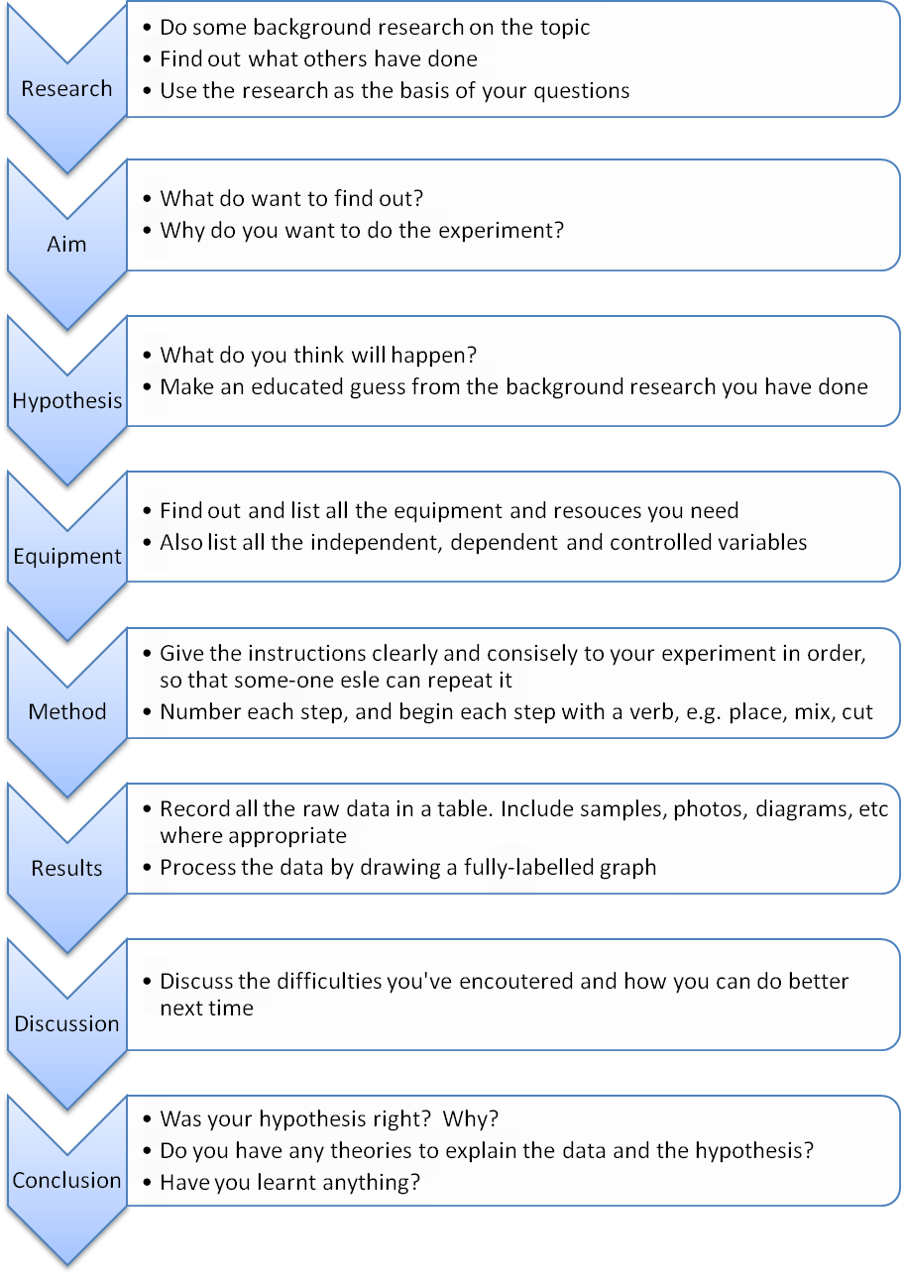

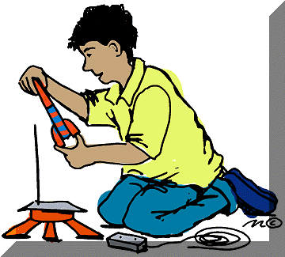**Beginning your TECHNOLOGY PROJECT**



**Beginning your research**



**PRESENTING YOUR PROJECT**

This is a very important step as your entry can only be judged on the information you communicate – so communication is very important.

To give you an idea of how to start, have a look at the board below and see how different sections are *typically* arranged in a ***logical sequence***:

Maximum width is 1.2m

Maximum height is 1.5m

Results/ Testing

Research

**Title**

Pictures

Aim

Conclusion

Method/ Concepts

Bibliography/

Acknowledgments

Graphs/Diagrams

You are limited to a table space of 1.2m wide X 0.75m deep X 1.5m high.

**MAKE SURE:**

* Your display is free standing and robust
* Your display is eye catching
* Your display is free standing and robust
* There are no spelling mistakes or errors
* Nobody will be offended by any of the content.
* Any graphics are relevant
* The information is clear and easy to read.
* All extra material/models/support information must fit inside your display area. *Oversized entries will not be accepted unless you have written permission from the science fair organisers.*
* Please check safety rules for any that may apply to your exhibit.

**ethics approval**

**Human ethics approval**

If your project involves adults and children as subjects (e.g., taste testing) then you need to get the informed consent of all participants. There is no human ethics committee, but information and guidelines are available from the website given below.

<https://www.royalsociety.org.nz/what-we-do/funds-and-opportunities/crest-awards/crest-and-ethical-practice/crest-and-ethics/>

**Animal ethics approval**

If your investigation involves animals, including humans you many need animal/human ethics approval **prior** to beginning your project. Refer to the flowchart below to determine whether or not you require ethics approval. Online application forms, information and ethics approval be obtained from [www.nzase.org.nz](http://www.nzase.org.nz).

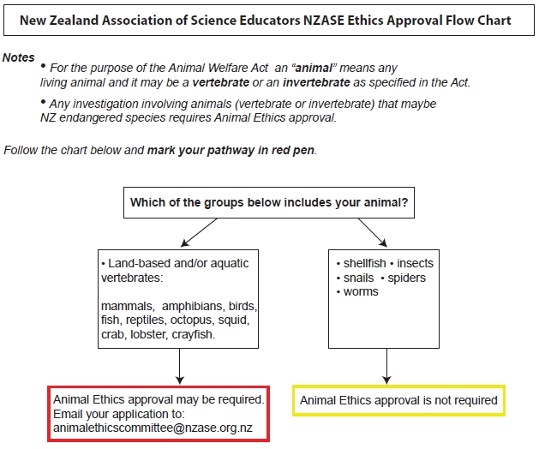

**safety infromation for you**

The following safety rules for construction of projects are necessary to prevent electrical fires and prevent injury to exhibitors and visitors:

**1**. Construction must be durable and stable when on display

**2.** Electrical Rules:

* Apparatus must be constructed following standard electrical safety laws. Check with an electrician or other qualified person.
* An AC 230 volt supply is available if required, but only NZ standards approved switches can be used and these must be suitable mounted.
* All wiring, switches and metal parts that carry current from a supply of 230 volts (or higher) must be completely enclosed by barriers that positively prevent observers from reaching into the exhibit and receiving an electrical shock. The barrier material can be clear to allow working parties to be seen.
* Properly solder and tape electrical joints.
* Wire used must be properly insulated for the voltage in use.
* A clearly visible sign must warn of voltages higher than 230 volts.
* Heating elements and light bulbs must be well ventilated and insulated to prevent hazard from fires.

1. Dangerous chemicals and explosives must not be exhibited.
2. No gas supply is available. You may only use a portable gas supply with permission from the organising committee.
3. Animals at home or school must be fed daily and their containers kept clean. A certificate of approval from the NZASE Animal Ethics Committee is needed for projects that involve manipulation of animals (See pg14). **NO ANIMALS ARE NOT TO BROUGHT ALONG FOR DISPLAY.**
4. Human participants in projects must be fully informed – see your teacher for information and before carrying out your investigation, get approval. (See pg14)

ALL PROJECTS WILL BE INSPECTED BY THE SCIENCE FAIR COMMITTEE AND THOSE THAT DO NOT COMPLY WITH THE ABOVE RULES WILL BE DISQUALIFIED.

**Responsibilities:**

The Science Fair Committee will take due care of equipment and exhibits on display but does not take responsibility for loss or damage.